Executive Summary
Potential 250 units apartment scenario using a best-case analysis that is most favorable to a developer under the Attainable Workforce Housing Performance Grant
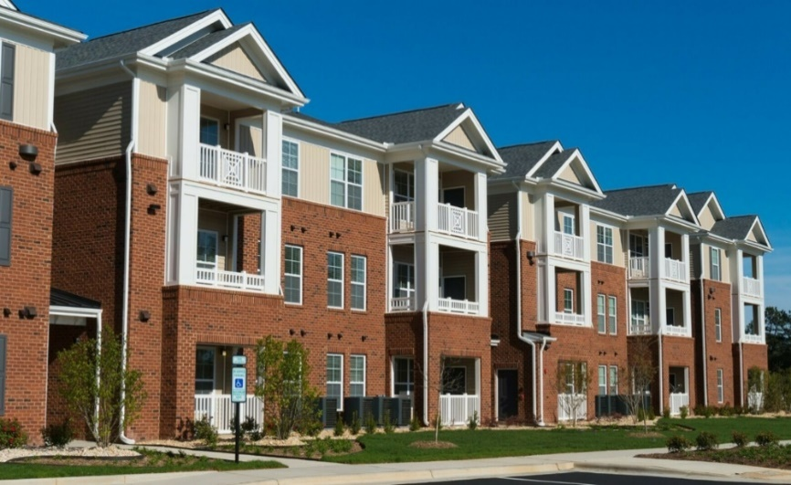
A new 250-unit apartment community in Virginia Beach exemplifies the type of development targeted by the Attainable Workforce Housing Performance Grant (AWHP) program. This memo presents a financial scenario analyzing the property tax impacts of such a 250-unit “attainable” workforce housing project under the AWHP grant. The analysis assumes a mix of affordable units optimized to maximize the developer’s tax benefit under the program’s incentives. Key findings are summarized below:
- Project Assessed Value: Based on comparable new multifamily projects, we assume an assessed value of roughly $220,000 per apartment unit, or about $55 million total post-construction value for 250 units¹. (For context, a Virginia Beach example projected ~400 units to be assessed at $88.3 million¹ – roughly $220k per unit, in line with our estimate.)
- Real Estate Tax Rate (2025): Virginia Beach’s real estate tax is $0.97 per $100 of assessed value². At this rate, a $55 million development would generate about $534,000 in annual property taxes at full assessment.
- AWHP Grant Incentive: By dedicating a substantial portion of units to affordable rents, the developer can qualify for an annual performance grant rebating up to 100% of the project’s new property taxes³. In our optimized scenario, 50% of units are kept affordable (≤80% AMI), including 20% of units at deeply affordable rents (≤50% AMI) – this mix meets the program’s highest incentive thresholds³. As a result, essentially all incremental real estate taxes from the new development are returned to the developer each year as a grant.
- Foregone Tax Revenue: Under this max-incentive scenario, the City of Virginia Beach forgoes approximately $510,000 in property tax revenue in the first year (this is the “incremental” tax above the pre-development land value)¹. Over a 15-year grant period, the cumulative taxes not collected would be on the order of $9–10 million (assuming modest 3% annual assessment growth)¹. If the grant is extended to the full 30 years permitted, the 30-year tax revenue foregone is estimated around $24 million in nominal terms. (Even with no assessment growth, the city would not collect about $7.7 million and $15.4 million over 15 and 30 years, respectively.)
- Base vs. Incremental Taxes: It’s important to note the city continues to collect baseline taxes on the land’s pre-development value (roughly $24k/year in this model), but nearly all new tax revenue from the improvements is offset by the grant¹. In effect, the development’s net new contribution to the tax base is near-zero during the incentive period, under the optimized affordable housing mix.
In summary, by maximizing the affordable unit mix to meet AWHP program criteria, a developer can legally achieve a 100% rebate of property taxes for up to 30 years. This yields a substantial financial benefit to the project, while the City effectively sacrifices the new property tax revenue in exchange for the creation of long-term affordable housing. The following sections detail the financial impact model, discuss policy implications for the City’s budget and housing goals, and provide recommendations on balancing these considerations.

Financial Impact Model
Assumptions & Development Profile: The scenario models a 250-unit multifamily rental development in Virginia Beach completed in 2025. We assume the project is a mid-rise “workforce housing” apartment complex. Drawing on comparable U.S. city data and local projections, we estimate a post-construction assessed value of approximately $55 million (e.g. 250 units × ~$220k each)¹. This valuation is consistent with new construction of this scale; for instance, a recent city analysis assumed 400 units of affordable apartments would be valued at ~$88.3 million¹. The FY2025 real estate tax rate is $0.97 per $100 of assessed value², meaning each $1 million of value generates $9,700 in city taxes annually. All units are assumed to be taxable (no separate abatements beyond the AWHP grant).
Affordability Mix for Maximum Incentive: To maximize the AWHP grant, the developer opts to make half of the apartments (125 units) affordable to households at or below 80% AMI. Within that affordable set, 50 units (20% of the total project) are reserved for very-low-income households at ≤50% AMI. This mix satisfies the program’s criteria for the maximum performance grant: the base grant percentage is proportional to the share of affordable units³, and because at least 20% of units are at ≤50% AMI, the program allows doubling the grant percentage up to a 100% tax rebate³. In effect, the development qualifies for an annual grant equal to 100% of the incremental property taxes generated by the new improvements.
Property Tax Calculations: At full occupancy and assessment, the total annual property tax on the development is projected at roughly $534,000 (calculation: $55,125,000 × $0.97 / $100)¹. Prior to development, the site’s land might have generated a small fraction of that (e.g. ~$2.5 million land value taxed at ~$24,000¹). The “incremental” tax from the new construction is therefore about $510,000 in Year 1. Under the AWHP grant agreement, the developer pays the full tax bill to the City, then receives an annual grant reimbursement of ~$510k, effectively negating almost the entire tax liability of the project in the first year¹. The city retains only the pre-existing $24k land tax.
Multi-Year Projections: We modeled the tax impact over 15 and 30 years, aligning with the program’s initial term and the possible extension. Real estate assessments in Virginia Beach historically grow ~3% per year on average², so we apply a 3% annual increase in assessed value (and taxes). Over the 15-year incentive period, the cumulative foregone tax revenue (the grant paid to the developer) is approximately $9.5 million nominal. If extended to 30 years, the total taxes not collected would reach roughly $24–25 million. By Year 30, the annual tax bill – which would otherwise be about $1.2 million by then – is still being rebated in full to the developer.
Table 1. Estimated Property-Tax Impacts of 250-Unit Project
Tax Impact | Year 1 | 15-Year Total | 30-Year Total
Incremental taxes rebated to developer (foregone by City) | ~$510,000¹ | ~$9.5 million¹ | ~$24 million
City tax revenue collected (base land tax only) | ~$24,000¹ | ~$0.4 million | ~$0.8 million
As shown, the vast majority of potential tax revenue from the new development is diverted back to the developer via the performance grant under this optimized-affordability scenario. The City’s opportunity cost is roughly half a million dollars per year, compounding with property value growth, which sums to tens of millions over the life of the incentive. In exchange, the community gains 125 affordable/workforce units that might not otherwise be financially feasible.

Policy Implications
City Fiscal Impact: The AWHP grant in this scenario represents a significant deferral of revenue that would otherwise fund general city services. Over 30 years, ~$24 million in foregone taxes is equivalent to roughly 2.8 cents on the tax rate (for one year’s $842 million tax base)², or about 0.06% of annual property tax revenues each year. While manageable individually, multiple large projects receiving 100% grants could become substantial. The program functions as a long-term tax expenditure – future revenue traded for affordable housing – requiring transparency and tracking so policymakers and the public understand the trade-offs.
Housing Affordability Benefits: In return for giving up tax revenue, the City gains 250 units of attainable housing, half of them (125) affordable to moderate and low-income households for the duration of the grant. This directly addresses Virginia Beach’s shortage of affordable rentals⁴. The targeted income levels (≤80% AMI, with many ≤50% AMI) serve teachers, police, nurses, and hospitality workers who struggle to find affordable homes⁴. There is a clear policy rationale: the City leverages future tax revenue to incentivize private developers to build units the market otherwise undersupplies.
Developer Perspective & Incentive Calibration: Even with full tax rebate, developers are not fully compensated for forgone rent. A city analysis found a 400-unit all-affordable project would yield $48 million less rent over 15 years than market rate, while the maximum AWHP grant (~$15 million) would offset only one-third of that gap⁵. Thus most projects will be mixed-income – blending market-rate units with affordable units plus the grant to bridge feasibility. The performance-based rebate ensures the developer only benefits if the project is built and pays taxes first³, protecting the City from upfront risk.
Economic & Community Considerations: The foregone revenue can be balanced against economic benefits such as construction jobs, resident spending, and future tax recovery after 30 years. Creating workforce housing also provides long-term social value (stability, reduced commute times). Still, policymakers must weigh whether the public good gained merits the revenue postponed. The AWHP shifts the cost of housing policy into the tax system via deferred revenue.
Equity and Targeting: The program’s structure rewards inclusion of very-low-income (≤50% AMI) units, promoting equity across neighborhoods. Enforcement through annual audits and occupancy verification is vital³. Non-compliance should terminate grants to protect taxpayers.
Capacity and Precedent: The City may wish to cap total annual AWHP grants or require “return-on-public-investment” metrics. Overuse of 100% grants could erode base-growth. Priority should go to projects delivering the greatest affordable-unit yield per tax dollar.

Recommendation
Support the Attainable Workforce Housing Performance Grant for this project, with safeguards for public accountability. The analysis shows a 250-unit project with optimal affordability can secure the maximum tax incentive, providing the developer the benefit needed to achieve 125 new affordable/workforce units consistent with City policy goals⁴. Therefore:
- Authorize a 15-year grant at 100% of incremental taxes, contingent on rents for at least 50% of units ≤ 80% AMI and 20% ≤ 50% AMI³. Include strict compliance monitoring.
- Plan for a 30-year extension conditional on performance review and property reinvestment at Year 15⁶.
- Mitigate fiscal impact by budgeting the ~$510k/year as a planned housing expenditure and exploring external offsets.
- Publish annual reports showing units created, income levels, and tax revenue foregone, allowing civic oversight by VBCCO and residents.
In conclusion, the AWHP grant can be a powerful, self-funding tool for expanding affordable housing. Properly managed, it aligns the City’s housing goals with fiscal prudence, ensuring Virginia Beach invests wisely in attainable homes for its workforce.

Footnotes
- Virginia Beach Economic Development analysis of attainable housing valuation scenarios, 2025.
- City Assessor’s Office, FY 2025 Real Estate Tax Rate Report, City of Virginia Beach.
- Virginia Beach Development Authority (VBDA), Attainable Workforce Housing Performance Grant Policy, 2025.
- City of Virginia Beach Housing & Neighborhood Preservation Department, Housing Needs Assessment and Housing Matters Blog, 2024.
- Virginia Beach Department of Economic Development, Affordable Housing Incentive Financial Model, 2025.
- VBDA Grant Agreement template, Section 10, “Capital Reinvestment and Extension Conditions,” 2025.

