Attainable Workforce Housing Program
Does It Do What It Is Supposed To
At What Cost To The Taxpayer

1) What incomes does the program target—and do they match our workforce?
Per the City’s own AWHP deck, “workforce” affordability is keyed to 50–80% of Area Median Income (AMI). For 2025, the income caps are (examples): 1-person at 60% AMI = $44,760; 80% AMI = $59,680. For 2-person households, 60% = $51,120; 80% = $68,160 (see the Silo affordability table, slide p.13). If we translate those to affordable rents at the standard 30% of gross income, we’re roughly here:
- 1-person: 50% AMI ≈ $932/mo; 60% ≈ $1,119; 80% ≈ $1,492.
- 2-person: 50% ≈ $1,065; 60% ≈ $1,278; 80% ≈ $1,704.
For context, the deck also cites median VB rent ≈ $1,730/mo (slide p.3). So units priced for 60–80% AMI are below current median rent and plausibly attainable for entry/mid-career public servants.¹
Implication:
- Single officers, teachers, firefighters in early/mid pay bands typically land between ~60–80% AMI for a 1- to 2-person household. Those bands fit the program’s 60–80% tiers, not the 50% tier.
- Families with kids (3–4 person households) at a single public-sector income may need the 60% band to keep housing cost ≤30% of income; 80% AMI rents improve headroom but 2–3BR pricing pressure remains—i.e., the program helps, but it doesn’t erase the squeeze.²

2) Will The Silo (200 units) meet that workforce need?
- Program fit: The Silo is 100% affordable with an average of 60% AMI, with units allowable across 50–80% AMI per the City’s slide deck (slides p.13–15). That profile aligns with the salary bands discussed above—especially singles/couples in police, fire, teaching, and public works.³
- Scale vs. need: Even if the City is short ~3,000 units, 200 units = ~6.7% of the gap. It helps—but it’s a incremental dent, not a cure-all.⁴

3) What about a 250-unit project (the “best-case” scenario memo)?
- A VB-specific 250-unit scenario (developer-optimized affordability mix) shows ~$510k in Year-1 incremental property tax being rebated to the developer via AWHP; 15-year cumulative foregone taxes ≈ $9–10M; 30-year ≈ $24M (City still keeps only the pre-development “base” land tax—~$24k/yr in that model). The public gets units; the City trades away most new tax revenue for 15–30 years.⁵

4) Taxpayer impact—who carries the load while grants rebate the new taxes?
- The Silo (200 units): the deck projects a 100% rebate of the incremental real-estate tax in Year 1—about $216,179 rebated; the City keeps only the base $47,821 land tax. Terms contemplate 30 years (with a conditional second 15). During the grant window, residents in these units consume services while the “new” taxes their building generates are mostly rebated—meaning the general fund (largely financed by existing residents) must still cover schools, police/EMS, roads, etc.⁶
- Civic equity lens: The AWHP is framed as “self-funding” (rebating only the incremental taxes). Practically, that still equals foregone revenue that could otherwise defray service costs or moderate future tax pressure on everyone else. Scale this across multiple projects and the opportunity cost becomes material over 15–30 years.⁷

5) Can this help retention of police, fire, teachers, public works?
Yes—partially. Given the AMI bands and rent math, The Silo’s 60–80% AMI targeting fits many early/mid-career public servants (singles/couples) and some families where there are two incomes. Where this won’t fully solve it: single-income families seeking larger units near job centers; and long-term retention if rent escalation outpaces wage growth (even within AMI caps).

6) Benchmarking—Richmond model (the template for VB AWHP)
Richmond’s similar program reportedly catalyzed many projects by rebating incremental real-estate taxes for 15–30 years—but it has drawn scrutiny for the long revenue holiday granted to new developments. VB’s AWHP mirrors that architecture; your brief flags both the upside (unit creation) and the tax-base deferral risk if grants are widely deployed at 100%. Translation: it’s an effective production tool that demands guardrails (caps, performance audits, transparent annual reporting).⁸

7) Net assessment—pros, cons, and options
Value proposition (Pros)
- Directly addresses workforce bands (50–80% AMI), improving affordability for early/mid-career public servants. (Silo’s unit mix aligns to this.)⁹
- Production now vs. later: converts vacant land to housing output; helpful against a ~3,000-unit shortfall.¹⁰
- Performance-based: grants are paid only if the asset exists, pays taxes, and maintains affordability, allowing claw-back/termination on non-compliance (per recommended terms).¹¹

Risk vectors (Cons)
- Foregone revenue during the grant horizon; the residents still draw on schools, public safety, and infrastructure funded by everyone else. (Silo: ~$216k Year-1; 250-unit scenario: ~$510k Year-1; 15–30 year totals are material.)¹²
- Scale vs. gap: 200–250 units are single-digit % progress against a 3,000-unit shortage—so multiple projects (and multiple tax rebates) would be needed to bend the curve.¹³
- Precedent risk: If 100% rebates become the norm, aggregate tax-base growth is muted until grants sunset; you need caps and ROI discipline.¹⁴
Comparative insights (Richmond & others)
- Pro: predictable, by-right-style tax rebate lowered financing friction; unit delivery accelerated.
- Con: long revenue deferral raised equity questions (who pays for incremental services in the interim) and calls for tighter program governance—both flagged in your packet’s analysis.¹⁵

8) Governance recommendations (no-nonsense guardrails)
- Cap total annual rebates citywide (and per-project) to protect baseline revenue growth.¹⁶
- Publish an annual AWHP scorecard: units by AMI tier, rent levels, occupancy, school impact, and taxes rebated vs. services consumed—in plain English for taxpayers.¹⁷
- Condition Year-16–30 extensions on capital reinvestment and proven compliance (as the deck recommends), and re-underwrite the minimum necessary rebate—don’t auto-renew at 100%.¹⁸
- Target unit mix to workforce demand (e.g., prioritize 1–2BR at 60–80% AMI near employment nodes; reserve a slice at ≤50% AMI for entry-level/solo earners).¹⁹
- Pair AWHP with zoning & fee tools (by-right density near transit, streamlined approvals) to lower cost without permanent revenue deferral.²⁰

9) Bottom line
- Can The Silo fill the need? Partially—yes for many singles/couples in police, fire, teaching, and public works (60–80% AMI). Less so for larger single-income families unless unit sizes/pricing are right. It’s material but modest versus a 3,000-unit gap.²¹
- Who pays while rebates flow? In practice, existing taxpayers carry more load during the 15–30-year rebate period because the City forgoes the new taxes from these buildings while services still scale. That’s the central trade-off to watch.²²

Strategic questions to pressure-test with Council/VBDA
- What cap (citywide and per-project) keeps AWHP impactful without hollowing out baseline revenue growth?²³
- What unit mix (by BR count and AMI) best fits local police/fire/teacher/public-works demand by district? (Right-sizing units can be more powerful than raw unit counts.)²⁴
- What’s the exit ramp at Year-15 (or 30)? Do we step down the rebate or require re-underwriting to the minimum necessary incentive?²⁵
- For transparency, will the City publish an AWHP annual report showing units created, compliance status, and taxes rebated vs. projected service costs?²⁶

Exhibits & where the numbers came from (by page)
- Median rent & cost-burden stat; program overview: deck *slides p.3–5.*¹
- Silo affordability table (50–80% AMI caps): *slide p.13.*³
- Silo fiscal terms & first-year rebate: *slides p.14–15.*⁶
- Program governance concerns & Richmond comparison: AWHP civic analysis memo.⁸
- 250-unit scenario—foregone tax totals: 250-unit best-case memo.⁵
If you want, I can translate this into a one-pager with charts (rent bands vs. AMI; unit contribution vs. 3,000-unit gap) to brief Council or your Civic League chairs.

Footnotes
- Slide Deck #1 and #2 Attainable Workforce Housing Performance Grant Applications, L43–L53
- Slide Deck #1 and #2 Attainable Workforce Housing Performance Grant Applications, L93–L99
- Slide Deck #1 and #2 Attainable Workforce Housing Performance Grant Applications, L86–L99
- Slide Deck #1 and #2 Attainable Workforce Housing Performance Grant Applications, L37–L45
- 2025 250 Unit Scenario.docx, L1–L19
- Slide Deck #1 and #2 Attainable Workforce Housing Performance Grant Applications, L112–L123
- 2025 250 Unit Scenario Impact Analysis.docx, L55–L78
- 2025 250 Unit Scenario Impact Analysis.docx, L1–L22
- Slide Deck #1 and #2 Attainable Workforce Housing Performance Grant Applications, L86–L99
- Slide Deck #1 and #2 Attainable Workforce Housing Performance Grant Applications, L37–L45
- Slide Deck #1 and #2 Attainable Workforce Housing Performance Grant Applications, L100–L110
- Slide Deck #1 and #2 Attainable Workforce Housing Performance Grant Applications, L112–L123; 2025 250 Unit Scenario.docx, L1–L19
- Slide Deck #1 and #2 Attainable Workforce Housing Performance Grant Applications, L37–L45
- 2025 250 Unit Scenario Impact Analysis.docx, L79–L104
- 2025 250 Unit Scenario Impact Analysis.docx, L1–L22
- 2025 250 Unit Scenario Impact Analysis.docx, L105–L135
- 2025 250 Unit Scenario Impact Analysis.docx, L105–L135
- Slide Deck #1 and #2 Attainable Workforce Housing Performance Grant Applications, L100–L110
- Slide Deck #1 and #2 Attainable Workforce Housing Performance Grant Applications, L86–L99
- 2025 250 Unit Scenario Impact Analysis.docx, L105–L135
- Slide Deck #1 and #2 Attainable Workforce Housing Performance Grant Applications, L86–L99
- Slide Deck #1 and #2 Attainable Workforce Housing Performance Grant Applications, L112–L123; 2025 250 Unit Scenario.docx, L1–L19
- 2025 250 Unit Scenario Impact Analysis.docx, L105–L135
- Slide Deck #1 and #2 Attainable Workforce Housing Performance Grant Applications, L86–L99
- Slide Deck #1 and #2 Attainable Workforce Housing Performance Grant Applications, L100–L110
- 2025 250 Unit Scenario Impact Analysis.docx, L105–L135

The FY 2025 “MFI/AMI” for the area is listed as $106,500 for a 4-person household¹

- FY 2025 Section 8 Income Limits Tables published by U.S. Department of Housing and Urban Development.
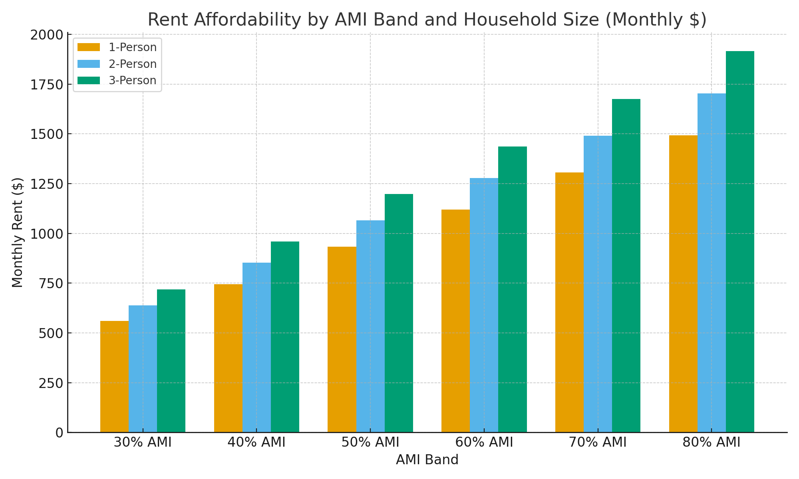

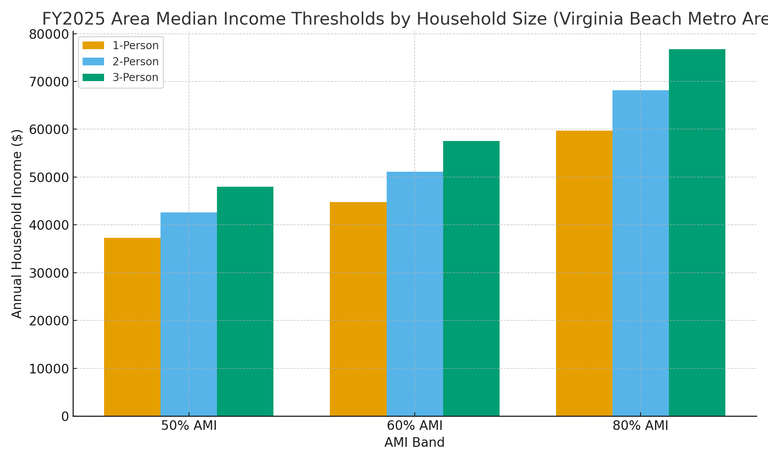

Executive Summary

Is AWHP good for a city? Potentially yes—it can unlock projects that otherwise wouldn’t pencil, add supply in the right AMI bands, and support workforce retention. But outcomes depend on tight guardrails (caps, reporting, compliance).¹ ² ⁴
Is it a good deal for taxpayers? It can be, if structured to deliver verifiable net public value (units, rents, location, durability) in exchange for time-limited tax rebates with strong oversight. Without caps and performance auditing, the opportunity cost (foregone revenue) can creep and shift cost burdens onto existing residents.¹ ² ⁴
Is it a good way to incent workforce housing? Yes, with conditions. Property-tax-based grants are a proven lever to close feasibility gaps for 60–80% AMI rentals—especially for mid-career public safety, teachers, and city staff—when paired with by-right zoning, fee relief, and expedited approvals.² ³
Is it sustainable? It’s sustainable if the City enforces a budget guardrail and “minimum-necessary” underwriting. The program is “self-funded” from incremental taxes, but that still represents foregone revenue until benefits sunset. Sustainability hinges on citywide caps, step-downs, and annual transparency.¹ ²

Value Proposition (Benefits)
Production now vs. later. De-risks deal pro formas so units get built where they’re needed (near job centers, transit), targeting households at or below 80% of Area Median Income (AMI) (VB-Norfolk-NN FY2025 MFI is $106,500 for a 4-person household).⁵ ⁶
Performance-based structure. Grants are paid only if the project exists, pays its bill, and maintains affordability; benefits can terminate for non-compliance.¹ ²
Workforce retention. Aligns with income bands for early/mid-career police, fire, teachers, and public works, where 50–80% AMI thresholds set rent targets below typical market median.² ⁶
Signal to capital. Predictable, codified incentives reduce financing friction, which Richmond reports has accelerated affordable multifamily delivery.¹ ⁴

Risk Vectors (Costs & Trade-offs)
Foregone revenue during the grant horizon. The “incremental” real-estate tax is rebated, so the General Fund doesn’t fully benefit until the grant sunsets—even as service demand (schools, public safety, roads) scales day one. That’s the core taxpayer trade-off.¹ ²
Program creep. If 100% rebates become standard across many projects, aggregate tax-base growth is muted; future councils may face pressure for rate increases or service cuts absent caps.¹ ²
Targeting risk. Units must be in the right locations and bedroom mix to serve actual workforce demand; otherwise, public dollars subsidize units that don’t move the retention needle.²
Governance/opacity risk. Without public dashboards, annual audits, and claw-backs, trust erodes and ROI goes unproven.¹

“Good for the City?” — When the Answer Is Yes
The program uses time-bound, performance-based grants with clear eligibility (≤80% AMI), transparent reporting, and automatic claw-backs.¹ ²
City imposes citywide and per-project caps on annual rebates, aligned to the budget.¹
Underwriting standard is “minimum necessary to close the gap” (not a flat 100% rebate by default), re-tested at renewals.¹ ²
AWHP is paired with zoning/entitlement fixes (by-right density, parking reform where applicable) and fee streamlining, so the City isn’t leaning solely on the tax grant to deliver affordability.¹

“Good for Taxpayers?” — The Litmus Tests
Unit delivery KPI: # of units by AMI tier (30/50/60/80%), by bedroom count, by geography; compare to stated shortfall.
Fiscal KPI: annual table of incremental taxes rebated vs. baseline service costs for residents in AWHP units; publish the variance.
Compliance KPI: affordability tests passed/failed, audits, enforcement actions, and claw-backs executed.
Sunset KPI: step-down profile and when each property transitions to full taxes.
If these KPIs are published and caps enforced, taxpayers can see tangible value for the forgone revenue.

“Good Way to Incent Workforce Housing?” — Best-Practice Stack
Use AWHP as the capstone, not the only tool: combine with by-right density near jobs, permit streamlining, and impact-fee adjustments to reduce the size and length of grants required.¹
Target 60–80% AMI for singles/couples in public safety/education roles, with a floor share at 50–60% AMI to catch entry-level earners.² ⁶
Prioritize 1–2BR units near employment nodes; selectively include 3BR where the data show family demand.
Time-box extensions (Year 16–30) to reinvestment milestones and re-underwriting to “minimum necessary.”

Sustainability — Governance Patterns That Work
Budget guardrails: hard cap on annual aggregate rebates and a per-project ceiling; anything above requires council super-majority.¹
Step-down curves: e.g., 100% → 75% → 50% over the term to reintroduce tax base sooner while preserving feasibility.
Public dashboard: annual “AWHP Scorecard” (units, compliance, rebate totals, per-unit public cost).¹
Independent verification: third-party compliance checks; public posting of audits and any claw-backs.
Sunset discipline: all renewals require a fresh “minimum-necessary” gap test; no automatic 30-year grants.¹ ²

Practical Options for Council/VBDA (Multiple Pathways)
Adopt caps + scorecard now and proceed with a limited initial portfolio; expand only if KPIs meet thresholds.¹
Pilot step-down rebates to speed tax-base participation without killing feasibility.
Pair AWHP with land-use fixes (density, parking, by-right near transit) to reduce required rebate sizes.¹
Create a “workforce targeting matrix” by district (police/fire/teachers/public works headcounts vs. unit types needed) to align awards with real demand.²
Establish a mid-term audit (Year 7–8) to recalibrate terms based on actual lease-up, rent levels, and taxpayer impact.

Final Take
AWHP can be a high-leverage, fiscally responsible tool—if the City treats it like an accountable investment, not an entitlement.
For taxpayers, the deal pencils when the City caps exposure, publishes a clear ROI ledger, and ensures units genuinely serve workforce bands.
It is sustainable when rebates are time-limited, stepped down, and re-underwritten—and when paired with zoning/approval reforms that lower costs without permanent revenue deferral.

Sources (footnotes)
- City of Virginia Beach — “City Launches Program to Promote Development of Affordable Rental Housing” (program announcement & structure), Sept. 24, 2025.
- City of Virginia Beach — Attainable Workforce Housing Performance Grant: program overview/policy (VBDA site).
- National Multifamily Housing Council (NMHC) — RCLCO Research Brief: tax-based incentives can reduce shortages and yield ROI when structured effectively; cautions on budget timing. Feb. 20, 2025.
- City of Richmond / Richmond EDA — Affordable Housing Performance Grants: 15-year rebates with potential 15-year extension; gap-financing and compliance requirements. May 2024 packet + program page.
- Novogradac — FY2025 MTSP Income Limits (HUD): VB-Norfolk-Newport News MFI $106,500 (4-person). Apr. 1, 2025.
- HUD User — FY2025 HOME Income Limits (VB-Norfolk-Newport News): 50/60/80% AMI thresholds by household size. Jun. 1, 2025.

